Database Storage Options:

Below are the supported archival database storage options

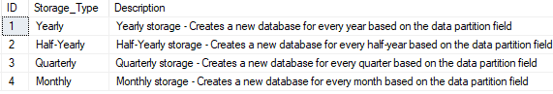

Archival Framework ERD Diagram:

